Sequence Patterns Associated with Disordered Regions in Proteins
S. Lise and D.T. Jones
PROTEINS: Structure, Function, and Bioinformatics, Vol. 58, pp. 144-150, 2005
Abstract
The relationship between amino acid sequence and intrinsic disorder in proteins is investigated. Two databases, one of disordered proteins and the other of globular proteins, are analyzed and compared in order to extract simple sequence patterns of a few amino acids or amino acid properties that characterize disordered segments. It is found that a number of reliable, nonrandom associations exists. In particular, two types of patterns appear to be recurrent: a proline-rich pattern and a (positively or negatively) charged pattern. These results indicate that local sequence information can determine disordered regions in proteins. The derived patterns provide some insights into the physical reasons for disordered structures. They should also be helpful in improving currently available prediction methods.
- Materials and Methods
a. Data set
We restrict our analysis to long regions of disorder with 40 or more residues, as they are most likely to be of functional importance. In the database, there are 112 long, disordered segments, for a total of 16,061 residues.
b. Pattern Language
Sequence patterns consist of a number of consecutive residues along the polypeptide chain, which is referred to as a pattern of length L. Out of these positions, only a certain number of residues J is specified. Two distinct types of patterns are considered: amino acid patterns in which specified positions are occupied by one of the 20 naturally occurring amino acids, and property patterns in which specified positions are characterized by a physicochemical property shared by a group of amino acids.
For example, a pattern of amino acid pattern with L=5 and J=4 is A-C-X-R-E, where X is and arbitrary residues. An example of property pattern with L=4 and J=2 is Hyd-X-Pos-X.
The number M of occurrences of a given pattern is defined as the sum of its occurrences in the disordered protein database M_{d} (number of matches), and in the ordered protein database, M_{o} (number of mismatches). The score S assigned to a pattern Γ is
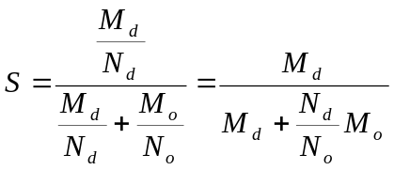
where N_{d} and N_{o} are the total number of L-residues-long segments.
A further constraint is imposed by requiring that a given pattern must occur at least M_{min} times in the combined database and in at least K_{min} different sequences in the disordered database.
Let f_{d} = N_{d}/(N_{d} + N_{o}) be the frequency of disordered segments of length L in the combined database. If sequence and structure were randomly associated, the probability p that, out of a total of M occurrences, the pattern is associated M_{d} times with a disordered region is
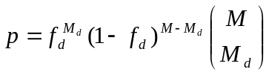
The expected number of randomly retained associations E is obtained by summing P₊ over all patterns Γ with M ≥ M_{min} and K ≥ K_{min}; that is,
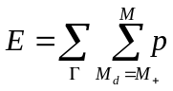

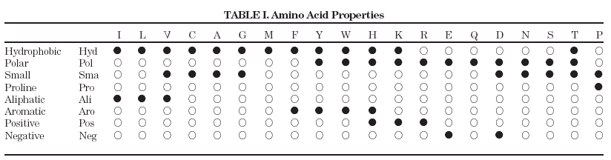

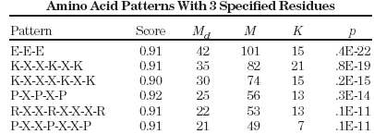
Created by : Chia-Chang Wang
Date : Dec. 24, 2004

